**Quick Starter Guide**

* SEARCH CONTACTS

Navigate to the contact manager webpage.

Enter a query on the search bar. Query can be a name, address, phone number or event date.

At least 3 characters must be entered.

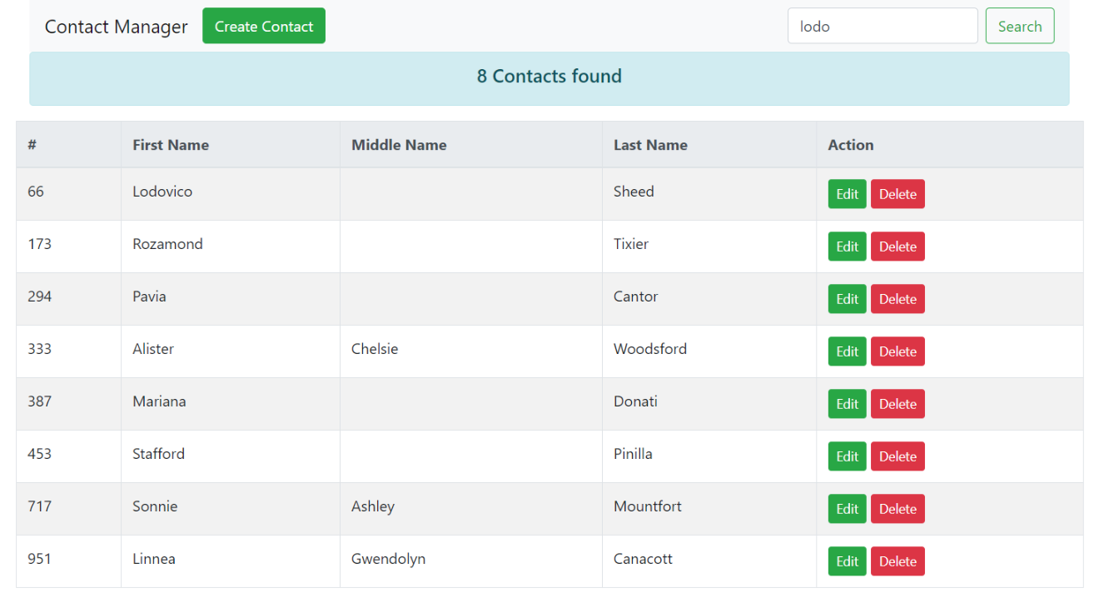

* ADD NEW CONTACT

New Address can be added using the “+ Add Address” button.

New Phone can be added using the “+ Add Phone” button.

New Event can be added using the “+ Add Event” button.

The “X” deletes the corresponding field-set.

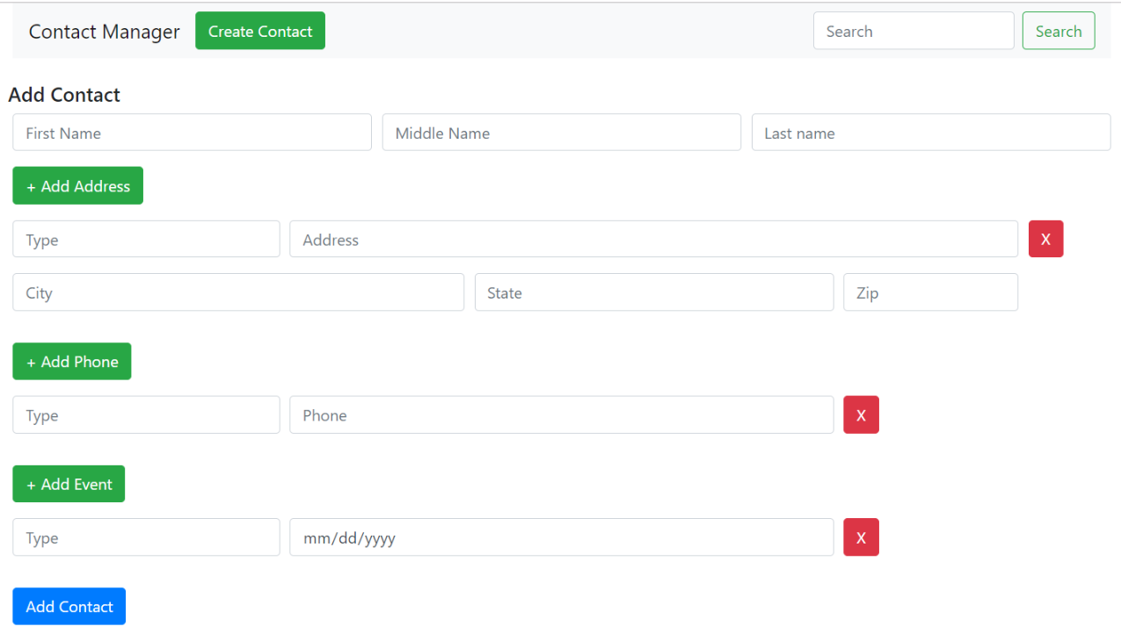

Enter all details and click “Add Contact”:

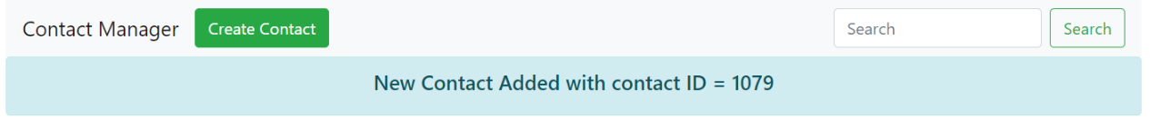

* MODIFY CONTACT

Search a contact.

Click on “Edit” next to the contact details on the search result.

This will open the edit page.

Modify/delete existing details or add new details to the contact.

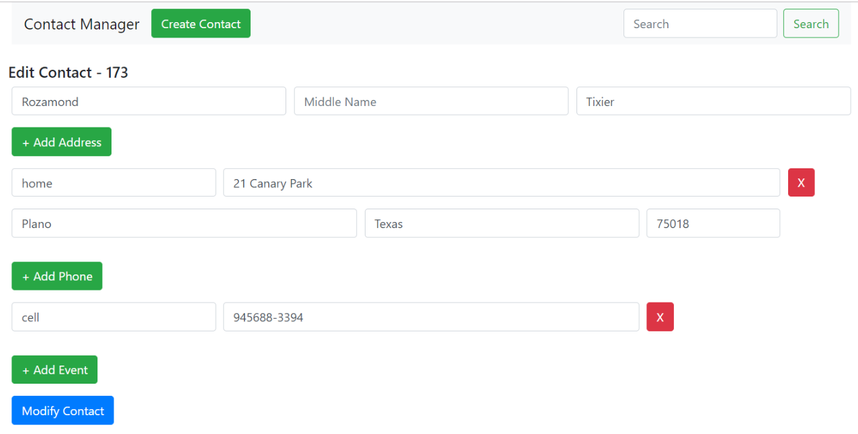

Click Modify Contact.

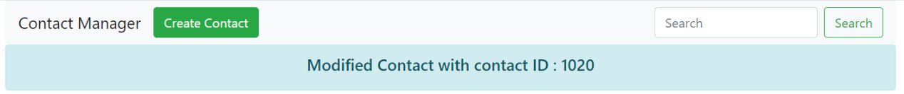

* DELETE CONTACT

Search a contact.

Click on “Delete” next to the contact details on the search result.

This will open the confirm Delete alert box :

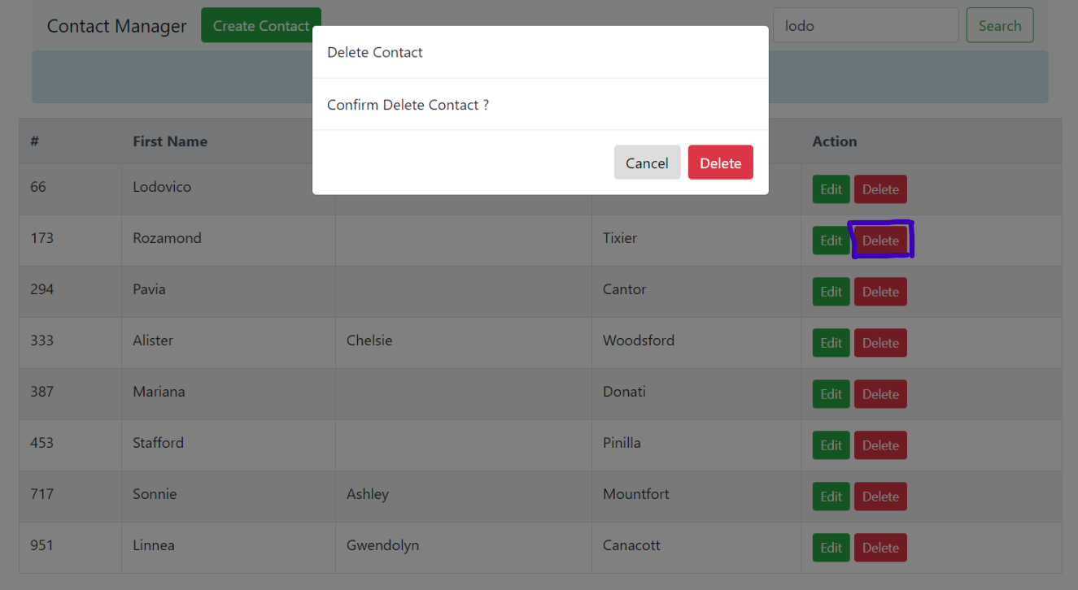

Click Delete to proceed or click Cancel to abort:

